DBMS LAB 0
1. What is SQL and Its Use?
SQL (Structured Query Language) is a standard language used to communicate with and manage relational databases. It is used to create database structures, store and retrieve data, modify and delete records, control user access, and manage database transactions.
Uses of SQL
- To create and manage databases and tables.
- To insert, update, retrieve, and delete data.
- To define the structure of database objects.
- To control access and permissions of database users.
- To manage transactions and maintain data consistency.
- To retrieve specific information from one or more tables.
SQL Commands
SQL commands are mainly classified into five categories:
- DDL – Data Definition Language
- DML – Data Manipulation Language
- DQL – Data Query Language
- DCL – Data Control Language
- TCL – Transaction Control Language

A. DDL – Data Definition Language
DDL commands are used to define, create, and modify the structure of database objects such as tables and databases.
Command | Use | Syntax and Example
CREATE | create a new database object such as a database, table, view, or other database structure. | CREATE TABLE table_name (column1 datatype, column2 datatype, ...);  CREATE TABLE students (  student_id INT,  name VARCHAR(100),  age INT,  email VARCHAR(150)  );
ALTER | modify the structure of an existing table by adding, modifying, or removing columns. | ALTER TABLE table_name  ADD column_name datatype;  ALTER TABLE students  ADD phone VARCHAR(15);
DROP | permanently remove a database object, including its structure and stored data. | DROP TABLE table_name;
TRUNCATE | remove all records from a table while keeping the table structure intact. | TRUNCATE TABLE table_name;

B. DML – Data Manipulation Language
DML commands are used to insert, modify, and delete data stored in database tables.
Command | Use | Syntax
INSERT | add new records or rows to a table. | INSERT INTO table_name (column1, column2, ...) VALUES (value1, value2, ...);  INSERT INTO students (student_id, name, age)  VALUES (2, 'Priya', 21);
UPDATE | modify or change existing records in a table. | UPDATE table_name  SET column_name = value WHERE condition;  UPDATE students  SET age = 21  WHERE student_id = 1;
DELETE | remove existing records from a table based on a specified condition. | DELETE FROM table_name  WHERE condition;  DELETE FROM students  WHERE age < 18;
MERGE | perform insert or update operations based on whether matching records are found between two data sources. | MERGE INTO target_table USING source_table ON (condition) WHEN MATCHED THEN UPDATE SET ... WHEN NOT MATCHED THEN INSERT (...);
C. DQL – Data Query Language
DQL is used to retrieve and organize data from database tables. The primary DQL command is SELECT, along with commonly used query clauses.
Command / Clause | Use | Syntax
SELECT | retrieve specific columns or all columns from one or more tables. | SELECT column1, column2, ... FROM table_name;  SELECT name, age  FROM students;
WHERE | filter records according to a specified condition. | SELECT column1, column2, ... FROM table_name WHERE condition;  SELECT *  FROM students  WHERE age > 18;

D. DCL – Data Control Language
DCL commands are used to control and manage permissions and access to database objects.
Command | Use | Syntax
GRANT | provide specific privileges or permissions to a database user. | GRANT privilege ON object TO user;  GRANT SELECT, INSERT, UPDATE  ON students TO user1;
REVOKE | remove previously granted privileges from a database user. | REVOKE privilege ON object FROM user;  REVOKE INSERT, UPDATE  ON students FROM user1;

E. TCL – Transaction Control Language
TCL commands are used to manage transactions and maintain consistency of data in a database.
Command | Use | Syntax
COMMIT | permanently save all changes made during the current transaction. Use after other commands. | COMMIT;
ROLLBACK | undo current transaction changes that have not been committed. Use after other commands. | ROLLBACK TO SAVEPOINT;
SAVEPOINT | create a temporary point within a transaction to which the transaction can later be rolled back (get back to). | SAVEPOINT savepoint_name;  INSERT INTO students (student_id, name, age)  VALUES (101, 'Rahul', 20);  SAVEPOINT sp1;
ROLLBACK TO SAVEPOINT | undo changes made after a particular savepoint without cancelling the entire transaction. | ROLLBACK TO SAVEPOINT savepoint_name;  UPDATE students SET age = 21 WHERE student_id = 101;  ROLLBACK TO sp1;
3) Write step by step procedure to install MYSQL.
1. Go to the official MySQL website>downloads
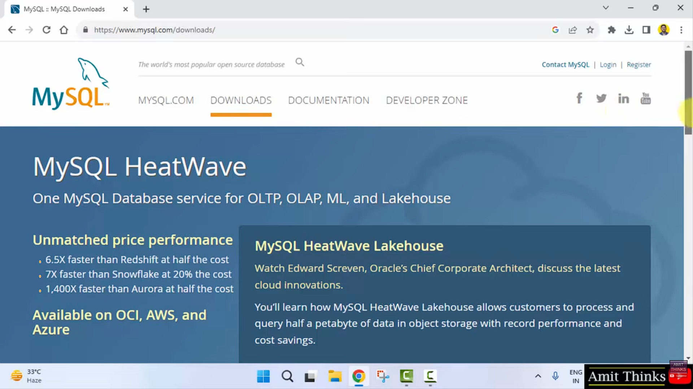
2. Click on MySQL Community downloads>MySQL installer (MSI) for Windows.

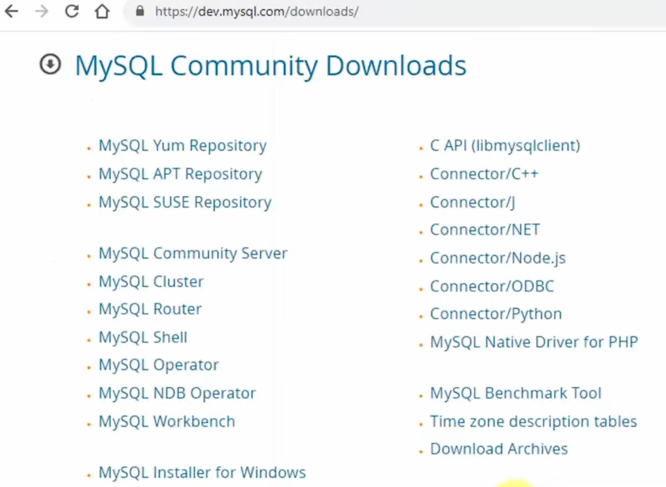
3. Download the MSI installer
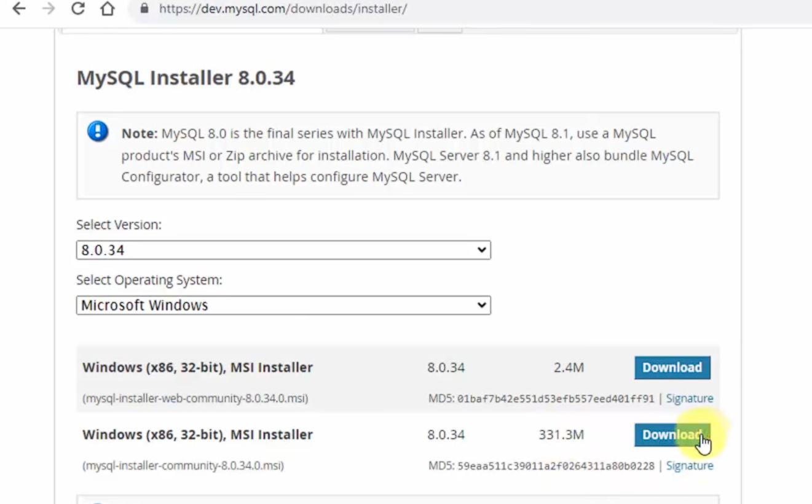

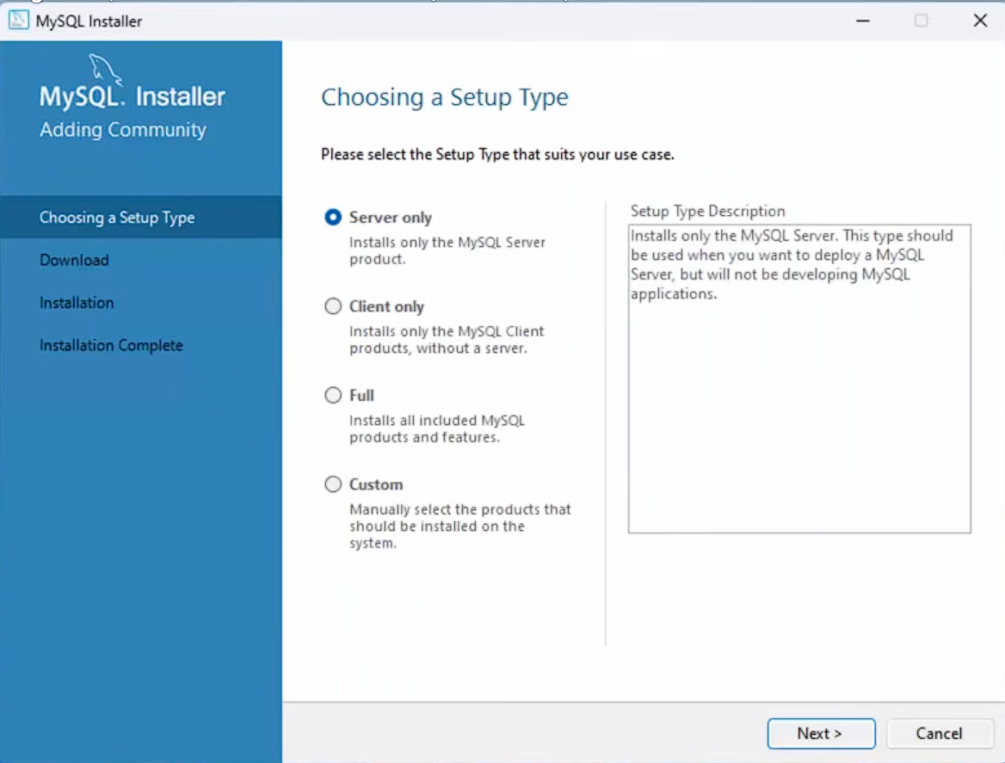
4. Run the installer, choose Custom Setup type.
5. Select product packages MySQL Server, Workbench and shell, click on next and execute
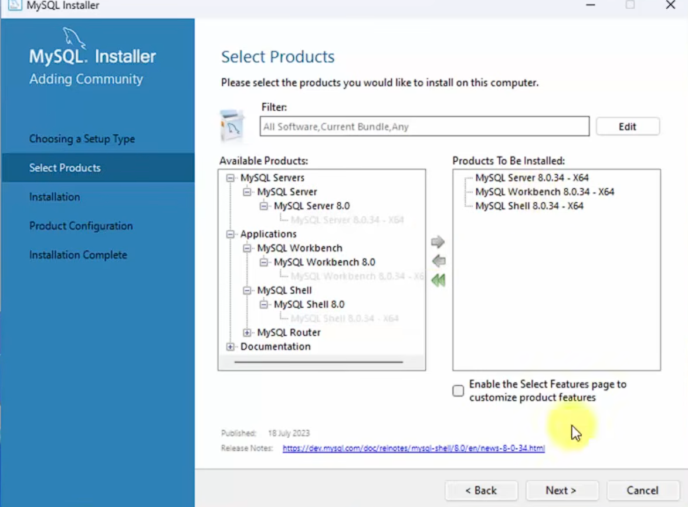

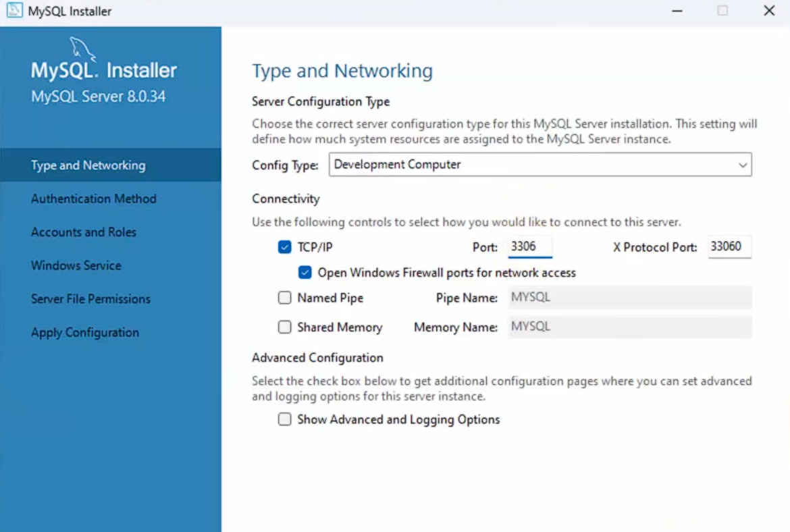
6. Configure the network settings as shown, keep the port 3306, click on next.

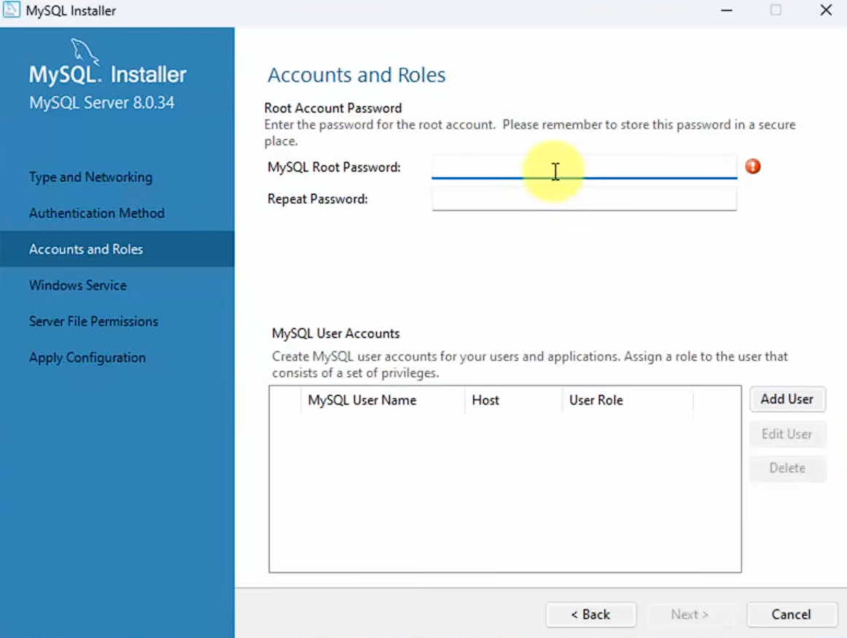
7. Set your password for MySQL. Click on next.

8. Click on next, allow full access for current profile and finish.

